**ASSIGNMENT 5**

**RELATION ALGEBRA**

**Submitted by:** AKSHAY JAIN

**Registration Number:** 17BCS002

**Allocation of Exercise: 1,2,3**

**Solution 1:**

* **Query:**

SELECT sID

FROM took

INNER JOIN offering ON took.Oid = offering.Oid

WHERE Dept = "CS" AND cNum = 100

* **View:**

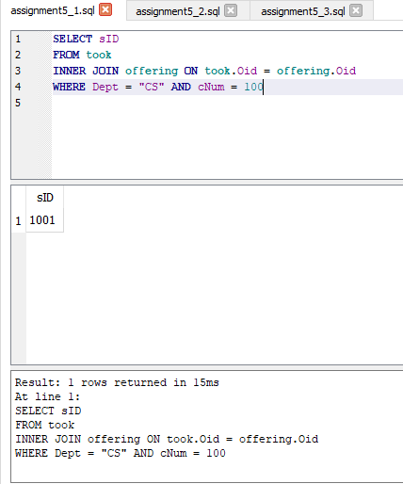

**Solution 2:**

* **Query:**

CREATE TABLE Temp1 AS

SELECT sID

FROM took

INNER JOIN offering ON took.Oid = offering.Oid

WHERE Dept = "CS" AND cNum = 200 AND marks >= 90

* **View:**

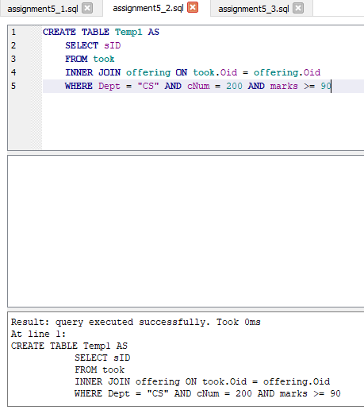

**Solution 3:**

* **Query:**

SELECT surName, FirstName

FROM student

INNER JOIN Temp1 ON student.sID = Temp1.sID

* **View:**

